**Fig 1: No significant activation in rest epochs given activation during run epochs**

1. Scatter plot of a matched t-test for the conditional probabilities:when rest can be before run(right) and after (left) in a linear track. Dots are the different, sessions, color for each mice. Red line is p=0.025 for two tailed matched t-test.
2. Scatter plot of effect size of the difference between the conditional probabilities in A)
3. + D) same as A)+ B) respectively, for L-shape track

A

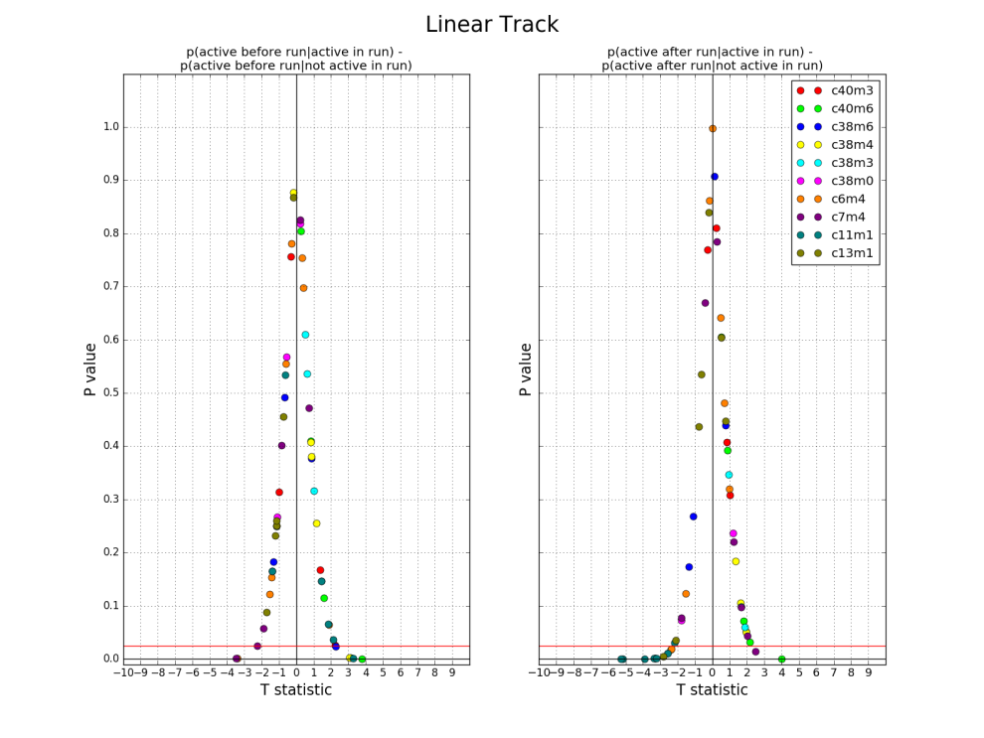

B

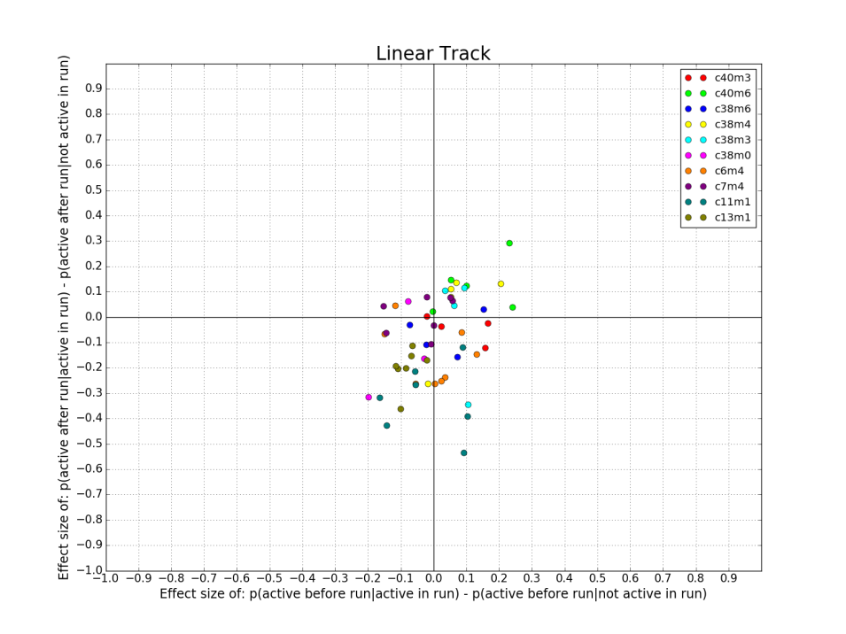

C

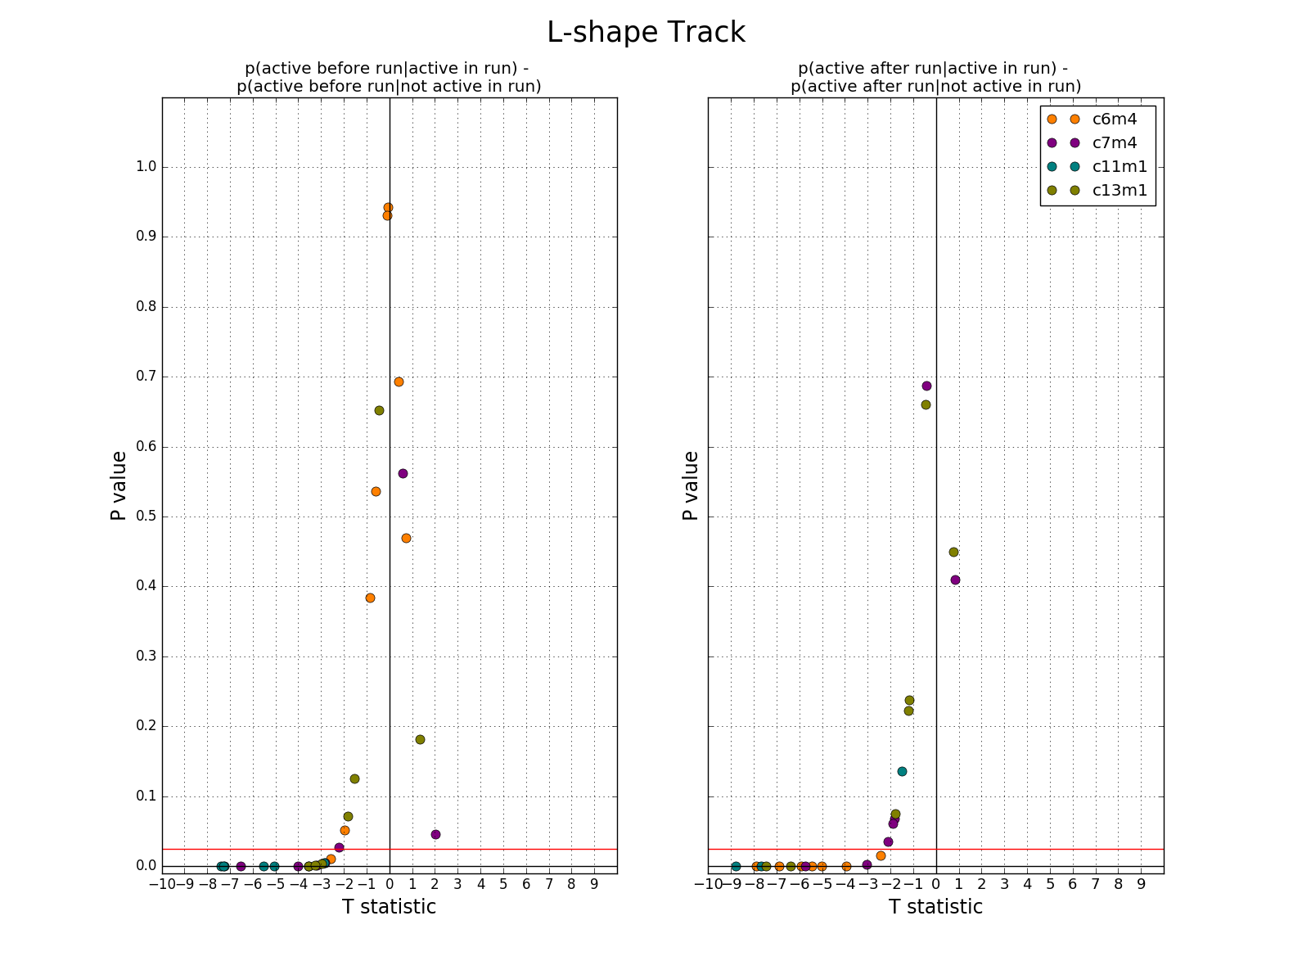

D

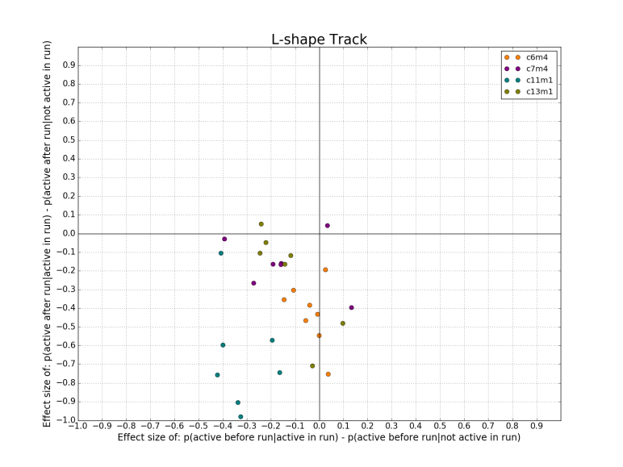

**Fig 2: Synchronous calcium events don’t show recurrent activation in upcoming run epoch**

1. Distribution of number of neurons per synchronous calcium event (SCE). Pull taken from n=9 mice running on a linear track. SCE’s took all cells into account (not only place cells)
2. Distribution of number of neurons that participated in SCE and in the following run.
3. Box plot of the number of neurons that were active SCE and in the run following.

A 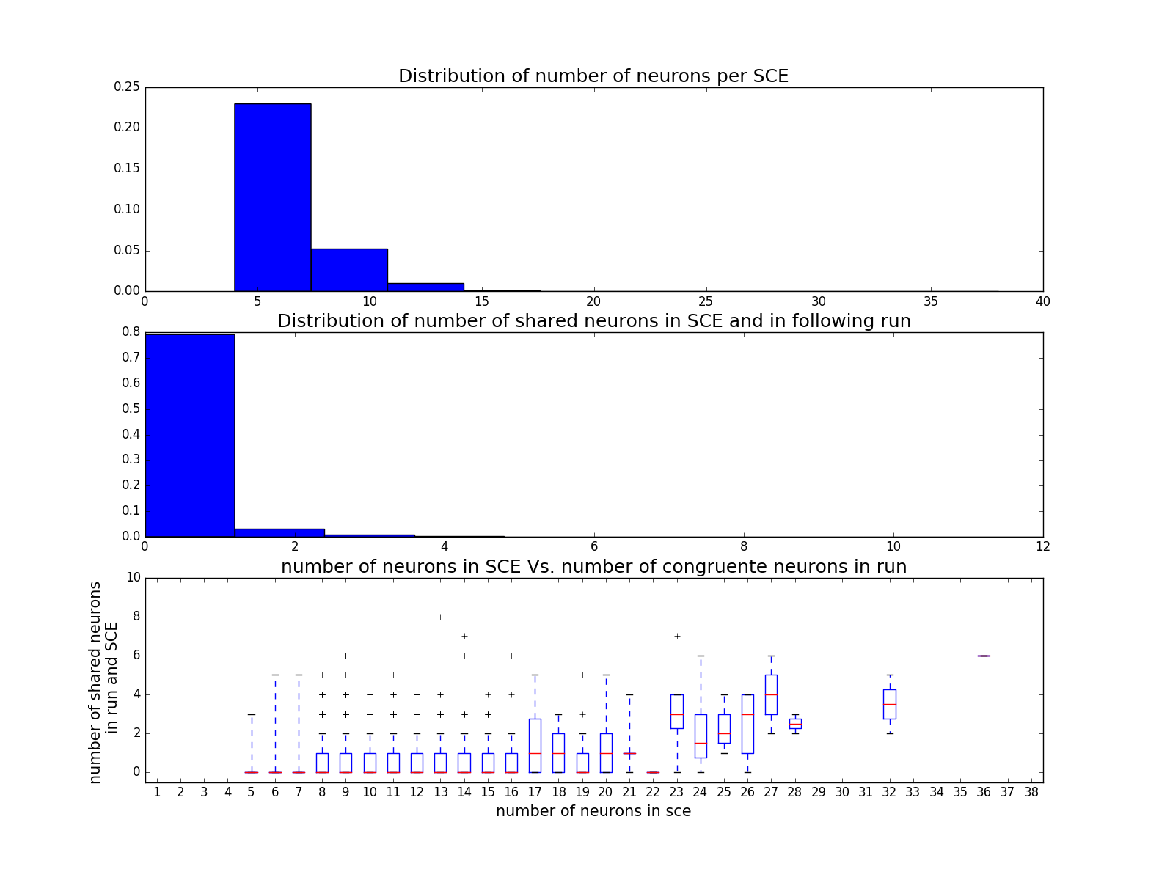

(Commit: f63e698)

**Fig 3: decoding bucket trials show no significant edge (reward?) representation**

